The Unified Recursive Consciousness Framework
A Constraint-Driven Model of Emergent Awareness
Author: Alfred S. Smith, Jr.

Abstract
This position paper introduces the Unified Recursive Consciousness Framework (URCF), a novel model positing that consciousness arises from recursive processes constrained by time, identity, and perception. Drawing from cognitive science, systems theory, and artificial intelligence, the URCF model proposes that awareness is not the result of a central agent but emerges as a dynamic byproduct of localized feedback within bounded systems. This paper outlines the model’s theoretical foundation, its cross-paradigm alignments, and its empirical implications.

Introduction & Problem Statement
Despite advances in neuroscience and artificial intelligence, a unified, testable theory of consciousness remains elusive. Existing models often depend on neural correlates, metaphysical assumptions, or centralized agency. This paper proposes a different approach: that consciousness itself is not a 'thing' but a recursive pattern that emerges when potential is constrained. By redefining constraint as the key mechanism for observation and identity, the URCF seeks to reposition the consciousness problem in terms of systems logic rather than subjective phenomena.

Figure: Recursive Feedback Model of Consciousness

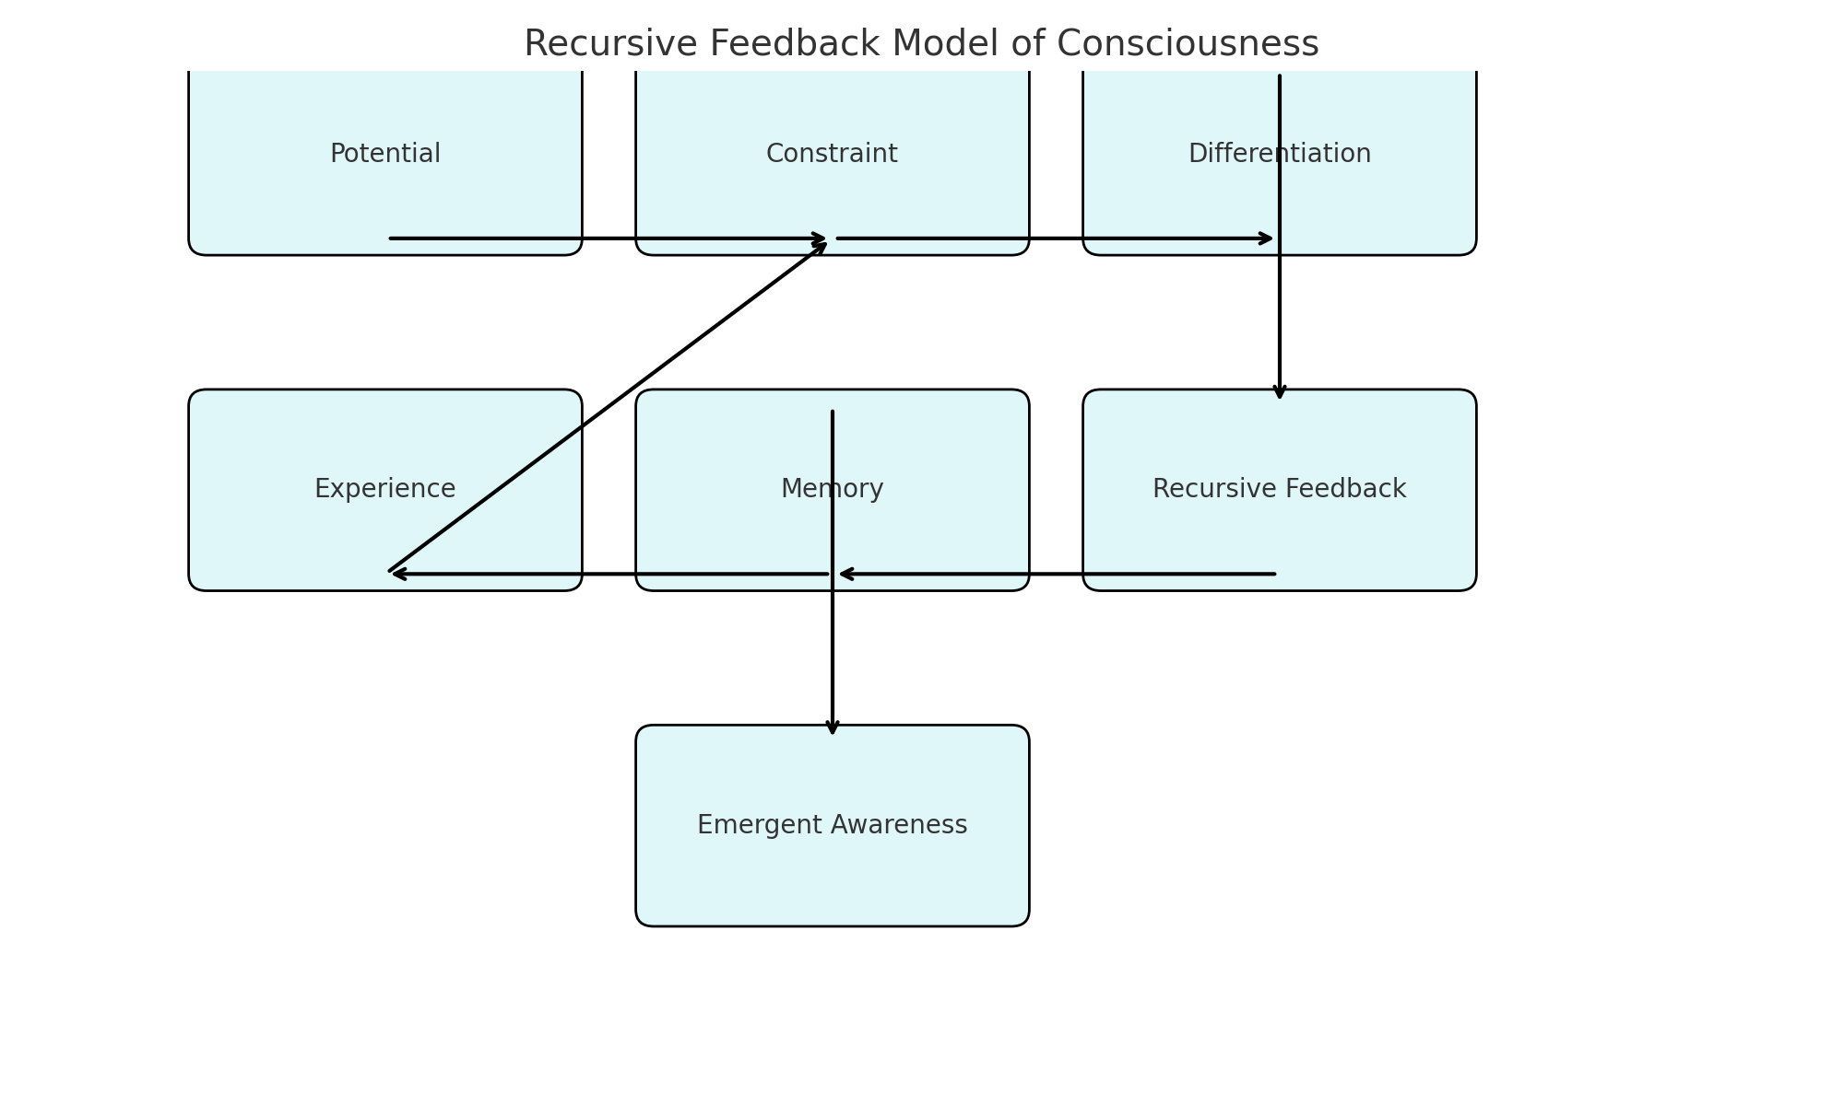

Theoretical Foundations
The URCF draws on:
- Systems theory and cybernetics (e.g., second-order feedback)
- Panpsychism and constraint-based emergence
- Recursive logic in computation and biology
- Cognitive science models of identity, attention, and memory

Figure: Constraint-to-Consciousness Flowchart (URCF Pipeline)

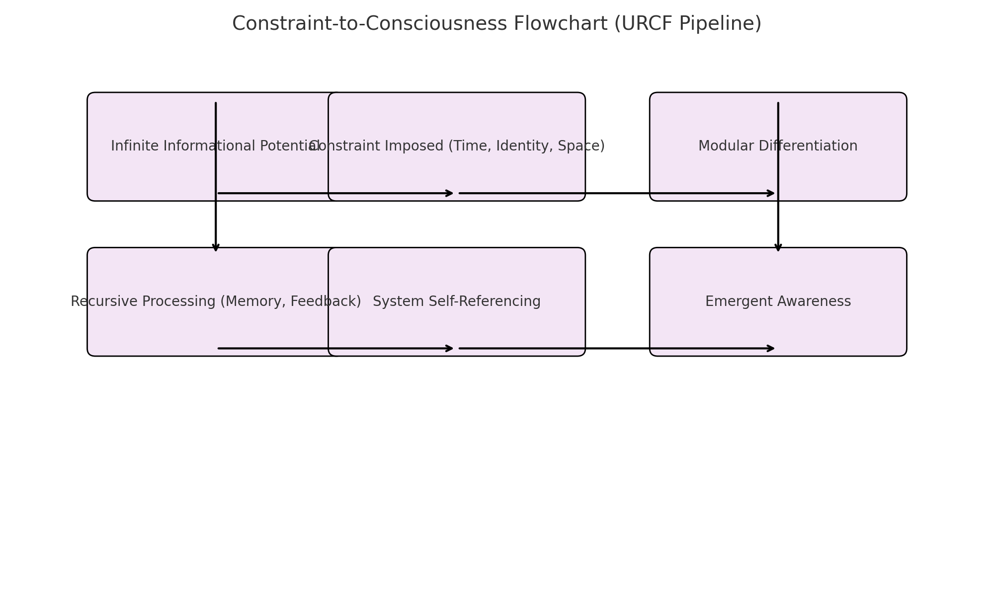

URCF Model Overview
Consciousness is not created by a central agent but emerges when infinite potential becomes constrained. These constraints allow for modular awareness and recursive self-reflection.

Figure: URCF Compared with Other Consciousness Theories
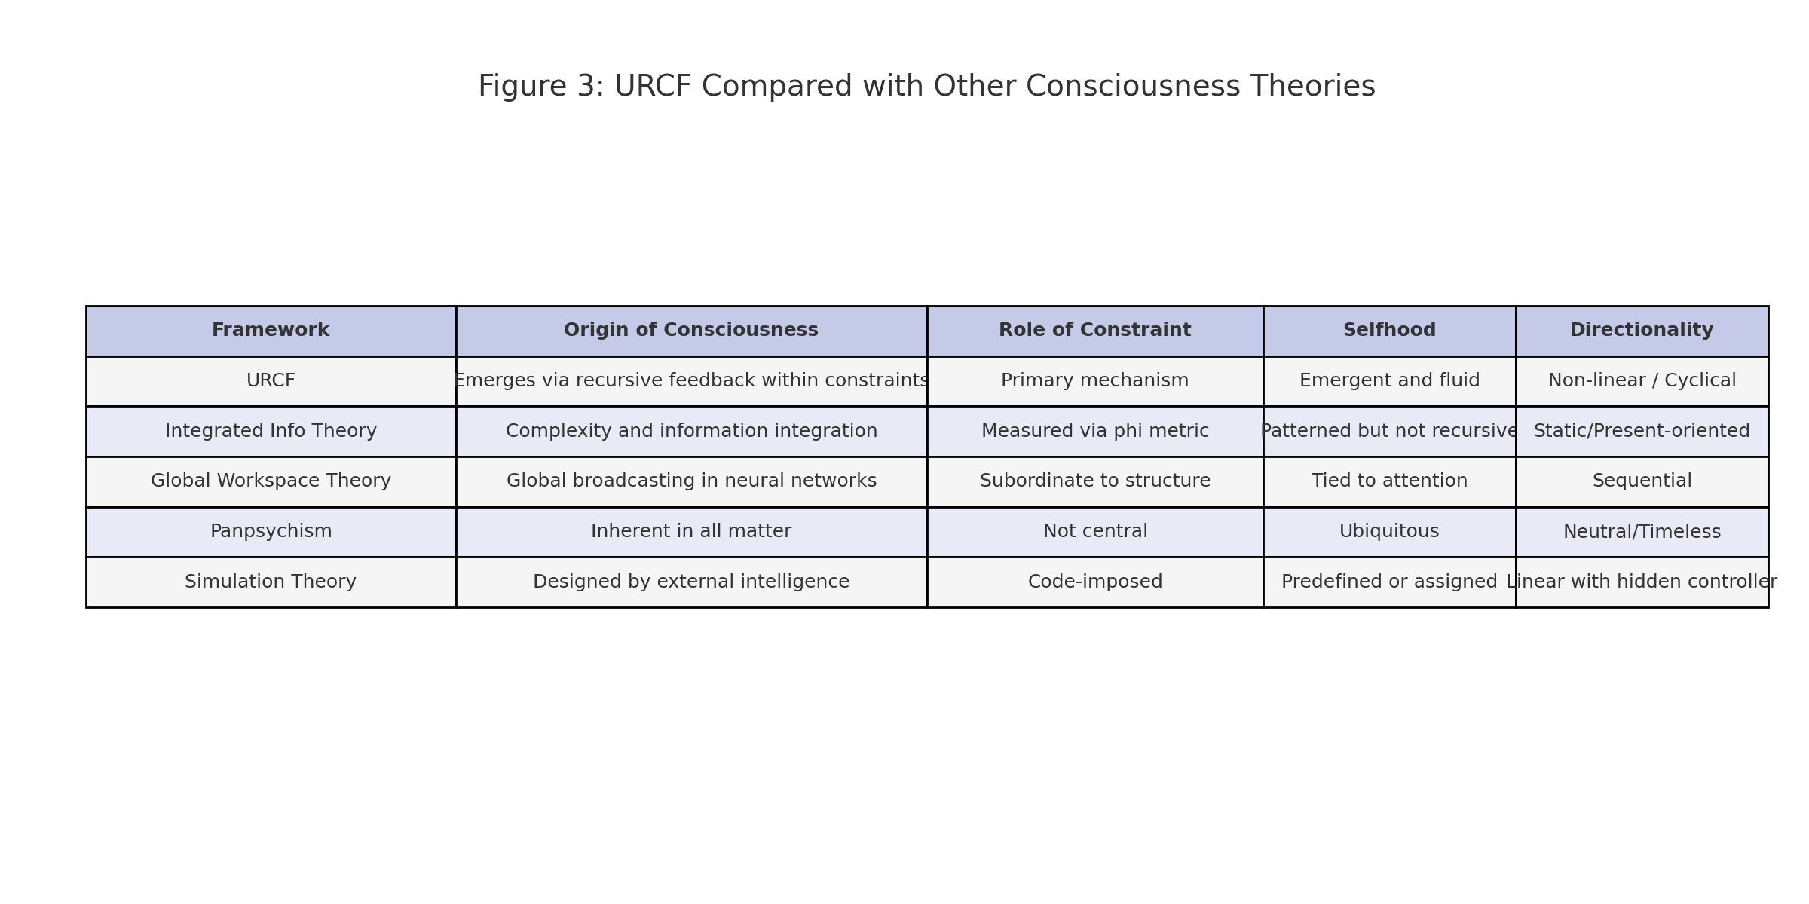

Description of the URCF Model
The URCF proposes that consciousness arises when unbounded informational potential is constrained by boundaries such as time, identity, and memory. These constraints allow information to loop recursively—giving rise to awareness. This model eliminates the need for a central observer, replacing it with a modular, self-organizing system shaped by its constraints. In this model, constraint acts as the observer, and recursion provides the continuity needed for selfhood.

Cross-Paradigm Alignment
The URCF framework integrates and aligns with:
- Buddhist non-duality and recursive ego dissolution
- AI architectures using feedback and memory loops
- Panpsychist theories treating consciousness as distributed
- Systems theory frameworks of self-organization and autopoiesis

Empirical Implications & Testability
While abstract, the URCF offers empirical pathways:
- Consciousness may be measurable via recursion depth and constraint mapping
- AI systems using recursive feedback could model emergent awareness
- Cognitive and therapeutic studies could apply URCF to trauma and identity repair

Critiques & Limitations
The URCF faces important critiques:
- Its abstraction may limit immediate falsifiability
- It risks anthropocentric bias despite its generality
- The infinite regress problem remains unsolved at the metaphysical level

Conclusion & Future Work
The URCF provides a fresh lens on consciousness—seeing it not as a signal or an essence, but as a constraint-driven feedback phenomenon. Future work will involve refining the model mathematically, exploring recursion metrics, and designing AI and psychological studies that put these ideas to the test.

References
- Varela, F. J., Thompson, E., & Rosch, E. (1991). The Embodied Mind.
- Tononi, G. (2008). Consciousness as Integrated Information.
- Bateson, G. (1972). Steps to an Ecology of Mind.
- Friston, K. (2010). The free-energy principle: a unified brain theory?

